**Part 4**

We implemented a modified version of Viterbi Algorithm to find the k best paths, known as k best parallel Viterbi[1].

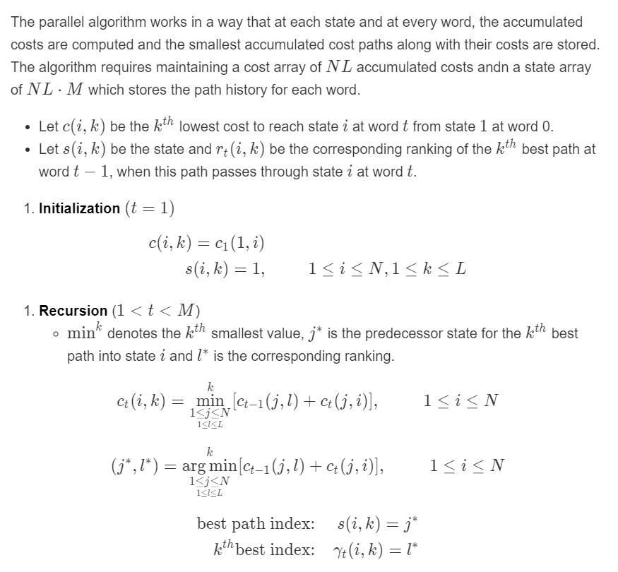

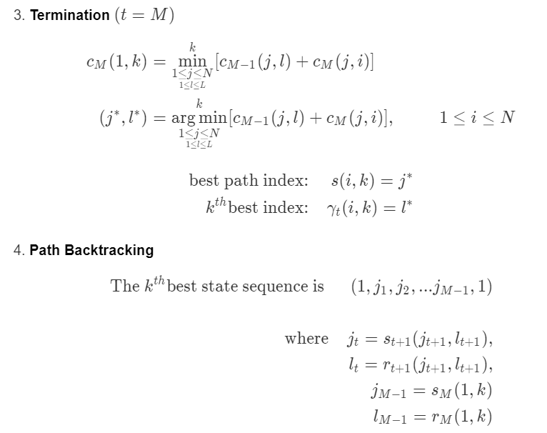

The best path found using this algorithm obtains the same result at the standard Viterbi, and the other 6 best paths found scored slightly lower in terms of recall score and precision, but still relatively reasonable.

**Part 5**

For the initial implementation of Hidden Markov Model (HMM) in this project from part 2 to 4, we have been using first order HMM, where emission parameters $b_{u}(x_{j})$ is dependent on the current tag to match the word, and the transition parameter $a_{i,j}$ is dependent on the transition from previous ${tag}_{i}$ to current ${tag}_{j}$. This might not give a good estimation for predicting the overall tags of a sentence. Thus, to improve the performance in our code, we will be implementing a second order HMM. The difference between the first order and second order HMM lies in its transition parameters. The second order HMMs’ transition parameter $a_{i,j,k}$ considers the transition from two previous tags i and j to current tag k. This should give us more thorough predicted labels.

However, second order HMM requires a greater amount of training dataset in order to produce good result as it requires three tags to be used for estimating transition parameters, which in some cases do not appear in the training set. To solve this problem, instead of calculating the transition parameter as P(i|j,k) = P(i|j,k), we need to consider the transition parameter from previous tag j to current tag i and transition parameter at current tag i. Hence, $P(i|j,k) = λ_{1}P(i|j,k) +λ_{2}P(i|j) + λ_{3}P(i)$

$$k_{3}= \frac{\log\left(Count\left(i,j,k\right)+1\right)+1}{\log\left(Count\left(i,j,k\right)+1\right)+2}$$

$$k_{2}= \frac{\log\left(Count\left(j,k\right)+1\right)+1}{\log\left(Count\left(j,k\right)+1\right)+2}$$

$$λ_{1}= k_{3}$$

$$λ_{2}=\left(1-k_{3}\right).k_{2}$$

$$λ_{3}=\left(1-k_{3}\right).{(1-k}_{2})$$

The sum of $λ_{1}+ λ_{2}+ λ_{3}=1$

**Result**

Transition

**First order HMM**

**Second order HMM**

Transition

Emission

Emission

Xj

Xj

**References:**

Park, J., Chebbah, M., Jendoubi, S., & Martin, A. (2014, September). Second-order belief hidden Markov models. In *International Conference on Belief Functions* (pp. 284-293). Springer, Cham.

Seshadri, Nambi & Sundberg, C.-E.W.. (1994). List Viterbi decoding algorithms with application. Communications, IEEE Transactions on. 42. 313 - 323. 10.1109/TCOMM.1994.577040.

Thede, S. M., & Harper, M. P. (1999). A second-order hidden Markov model for part-of-speech tagging. In *Proceedings of the 37th annual meeting of the Association for Computational Linguistics* (pp. 175-182).

1. Seshadri, Nambi & Sundberg, C.-E.W.. (1994). List Viterbi decoding algorithms with application. Communications, IEEE Transactions on. 42. 313 - 323. 10.1109/TCOMM.1994.577040.